A Practical Model for Integrating Information Technology Resources into the Egyptian Educational System

Rita Korin Karl
Pal-Tech, Inc., Egypt
rkarl@pfc-egypt.com

Ahmed El Sharkawy
Pal-Tech, Inc., Egypt
ashark@pfc-egypt.com

Abstract: The Education Technology in Schools project (Ed Tech in Schools) is charged with assisting Egyptian schools to create a practical and competitive educational environment using modern methodologies and computer technology over a three-year implementation period. The result of the demonstration project will be to provide classroom teachers with the tools and techniques they need to educate a new generation of computer literate students. These enhanced educational environments will be models for other schools who wish to create a new competitive workforce generation. The project is also charged with assisting the Egyptian government and the United States Agency for International Development (USAID) to build community awareness, acceptance, and expertise in information technology for students, teachers, parents, and community members. Demonstration schools will be assisted in the development of sustainability strategies for continued implementation post-project.

Introduction

Pal-Tech, Inc. a contractor for the United States Agency for International Development (USAID) manages the Partners for a Competitive Egypt (PfCE) project in Cairo, Egypt which includes the Educational Technology in Schools program (Ed Tech in Schools). This activity supports an initiative of the Egyptian National Information Technology Plan to introduce and strengthen information technology skills and e-learning in pre-university education, as a tool for learning other subjects and as a skill. The Plan initiative emphasizes networked education as the primary approach to achieve these objectives (Ministry of Telecommunication and Information 1999).

Recognizing the priority of this approach to the Egyptian Ministry of Education and the Ministry of Communications and Information Technology and its potential as a long-term vehicle for contributing to a more competitive Egyptian workforce, USAID initiated the demonstration program through PfCE to support their goals by providing technical assistance for use of information technology and networking in pre-university education; designing a scalable system architecture and connectivity plan that could be adopted to other schools with varying levels of resources and degrees of e-readiness; selecting and developing a training curriculum and instructional resources for educators and administrators; providing computer software and hardware for a limited demonstration at fourteen schools (ten private and four public); facilitation of the replication and expansion of the pilot to a larger set of schools; and developing a non-governmental organization capable of managing complex sustainable projects with multiple funding sources.

Schools in seven governorates across Egypt were selected based on USAID selection criteria that included delivering a K-12 curriculum and teaching math and science in English (a “language” school). The project includes a range of public and private, rural and urban, high and low income, and both boys, girls and co-ed schools. In the first year, 2002, needs assessments were completed and the training and technology model was designed and developed. Years two, three and four (2003-2005) comprise implementation of teacher and administrator training programs and the lay down of technology infrastructure.

Project Design

Information technology education and the use of technology in education have undergone major developments over the past three decades. New digital technologies and their declining costs are transforming the way people learn. The Ed Tech in Schools model enables Egyptian students and their community to participate in this learning revolution and benefit from the new skills and educational outcomes. The activity emphasizes broad information dissemination of the model and its results for replication and use in the entire Egyptian educational system.

Earlier uses of technology in education focused on the abilities of information technologies to transmit information from teacher to learner, and to access, manipulate, and transmit information. While this approach utilizes many of the technological advantages of earlier technology tools, it does not fully utilize the powers and strengths of present-day technologies, and relies on an outmoded educational paradigm, that of transmission of educational content from teacher to learner.

Over the latter part of the 20th century educational research has rejected learning as a transmission and receipt of information. Learning is an active process in which the learner constructs new understandings of their surroundings as a result of discovery, exploration and dialogue. In this paradigm people do not acquire or receive information but further create and initiate ideas and knowledge. Computers and the internet are excellent mediums for creation and expression, and are thus particularly suitable for transforming passive learning and education into a more active and participative model. Instead of using computers only to access websites or download music, learners can now create their own projects, websites, multimedia, personal simulations, and robotic applications. Each of these uses of instructional technology provides a context in which the student may access, discover, and construct knowledge through a self-directed learning process (Means et al. 1993).

To enable students to use technology in this more progressive and creative capacity, education programs have to transition from aiming at technology familiarity and eradicating technology illiteracy to providing digital fluency. With the declining cost of computing and networking, and the growing public and donor programs extending technology to the less privileged, the digital divide separating developing from developed nations is changing from a divide based on an “access gap” to one based on a “digital fluency gap” (Resnick 2002). The Ed Tech in Schools project is undertaking technical assistance and training initiatives to enable Egyptian education to contribute to bridging this digital divide and enhancing digital fluency in schools and their communities. It supports educational events aimed at building Egyptian capacity in the areas of e-learning and integration of technology using interactive learning methodologies.

In addition to eradicating technology illiteracy, the project trains administrators and educators beyond the familiarity and basic knowledge level where technology is used as an information source, to a “digital fluency” stage. Educators are trained to move into a facilitative role in the classroom, helping students to use technology resources to express themselves and to gain confidence as active learners capable of creating useful products and knowledge, and of using technology to learn school subjects and other useful life skills that go beyond those of school subjects. Computer-related skills are vital in today’s marketplace, and while these skills are best taught through the actual use of computers, it is important that technology be integrated throughout the K-12 curriculum, and not merely used to impart technology-related knowledge and skills.

The ASP Model

The system is designed to use an applications service provider (ASP) host as the central point of administration for the network. The ASP model creates a client server infrastructure that reduces the cost per school by eliminating the necessity of providing individual network services at each school and provides the ability to add additional schools to the ASP in the future. A central data center provides all the network services needed by the project schools including internet and filtering, network support, website hosting, an on-line Educator’s Resource Network, e-mail and collaboration tools and web-based school management software for each school.

Each school is connected to the ASP with a broadband connection and a server at the school that acts as a replication partner, a caching facility, and a proxy for the school (Fig.1). Computers and desks are provided to schools at a student to computer ratio of 5:1 in the classroom as recommended by the U.S. Department of Education (U.S. Department of Education 2002), and at a 2:1 ratio in the computer labs, thus providing a structure for student-centered small-group learning methodologies. Enough computer labs are provided to meet the Egyptian government requirements of each student attending two computer classes per week. Science labs are provided with five computers to assist in the delivery of science curriculum. Every classroom, computer and science lab also receives one computer for use by the teacher with a printer and scanner. Each classroom is provided with LanSchool software which allows teachers to control student machines and allows any screen to be viewed on any machine. This reduces the need for a projector in each room and contributes to the project-based, student-centered approach to curriculum delivery.

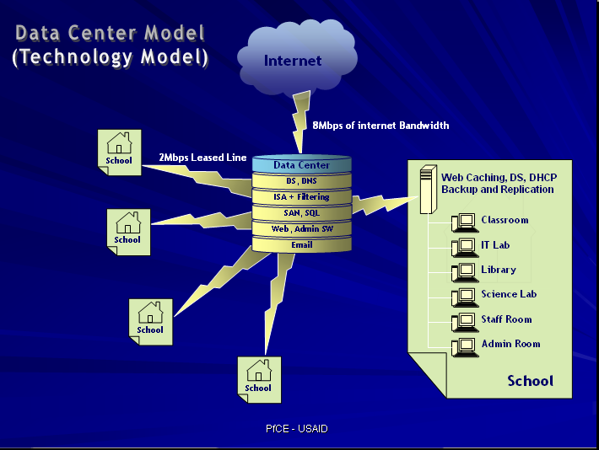

Figure 1. Data Center (Technology) Model

Staff rooms are equipped with a teacher to computer ratio of 5:1 providing teachers with the technology necessary for lesson plan development, assessment and administrative tasks. Each staff room is equipped with one printer and scanner. Libraries are provided with five computers, one for the librarian to use for checking out materials and administrative tasks and the rest for student use. Libraries are also provided with one printer, one scanner, a CD-writer and a projector for use in the library and for school-wide presentations. Four computers are provided in the administration for use by key administrators and financial directors. Each administration suite of offices receives one printer and one scanner for administrative purposes. School contributions include classroom space, releasing teaching staff for training, computer supplies, initial connectivity fees for electricity and all electricity bills.

The Educators Resource Network (ERN) (Fig. 2) hosted by the ASP provides bilingual Arabic/English communication tools (chat rooms, bulletin boards and listservs) and serves as an educational portal for educational resources for teaching the Egyptian curriculum, to assist in the development of lessons by educators (housed in a searchable on-line database), and for the assessment of those lessons. It is approximated that over 6,000 bilingual Arabic/English lessons covering most of the topics of the Egyptian curriculum will be developed by educators over the course of the project training alone, and others may populate the database through the ERN’s uploading capability through a quality screening process. All developed lessons are available on-line to any educator at any school in Egypt over the internet.

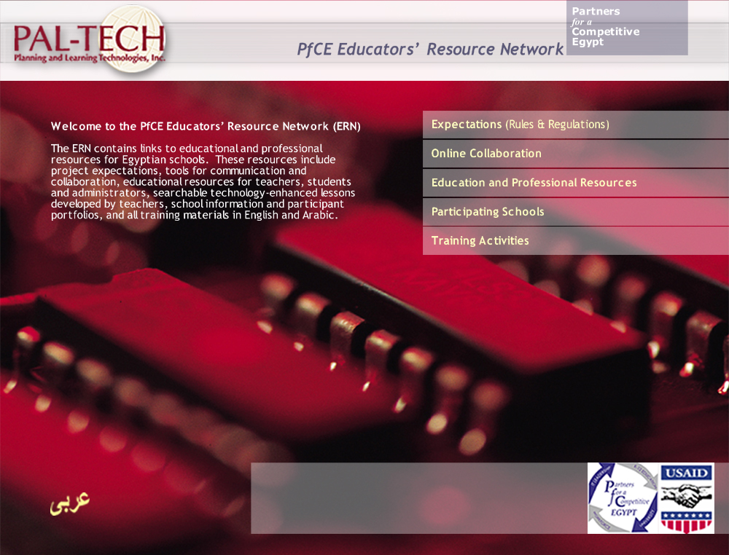
Figure 2. Educator Resource Network Home Page (English Interface)

Educational Applications

The project introduces technology from the earliest schooling stages—both as a learning tool for other subjects and as a specialty area preparing youth for direct employment or pursuing successful careers in computer sciences and related fields. Tools which encourage constructivism and creativity, and which maximize the fun in learning are emphasized from the earliest stages. Educational software and teacher training on that software for kindergarten and primary levels includes word processing, typing, graphics, multimedia and the internet, and progresses to more workforce-oriented software at the preparatory secondary stages including publishing, web-design, multimedia, logo programming, robotics, and computer assisted drafting. For all students in the demonstration, the program will provide a minimum of two classes a week within the regular school day in computer labs, in addition to use of computers and the Internet as a learning tool and resource in all other subjects in the classroom.

Windows XP and Microsoft Office Professional is the baseline software used in initial training for educators and administrators. Microsoft’s agreement with the Egyptian Ministry of Education covers all the licensing for schools at no cost including the operating system upgrade to the latest version, Microsoft Office Professional with Front Page to the latest version, and client access licenses for e-mail and web-access.

Specific educational software for the integration of information technology into the Egyptian curriculum is provided for students and teachers that is age and grade appropriate. Educators are trained in the use and integration of this software using project-based methodology that allows educators to work at their own pace and develop materials for use with their students. The educational software selected for use is a minimum spread of applications that are age specific across the realm of all academic subjects and are representative of the skill sets they will need to become competitive in the future workplace (Tab. 1). Selection of software is based on the National Educational Standards Technology Project for Students: Connecting Curriculum and Technology from the International Society for Technology in Education (Knezek et al. 2000).

Title | KG/Primary Students | KG/Primary Teachers | Prep&Sec Students | Prep&Sec Teachers | IT Lab/ Library Student | IT Lab/Library Teacher | Staff Room | Admin
OS XP (English/Arabic) | x | x | x | x | x | x | x | x
Norton Anti Virus Corporate Edition | x | x | x | x | x | x | x | x
Microsoft Office (English/Arabic) | x | x | x | x | x | x | x | x
Kid Works | x | x |  |  | x | x | x
Kid Pix Studio | x | x |  |  | x | x | x
Hyperstudio Teacher |  | x |  |  |  | x | x
Hyperstudio Student | x |  |  |  | x | x
Arabic Typing Tutor | x |  | x |  | x | x
Kidspiration | x | x | x | x | x | x | x
Inspiration |  | x |  | x |  | x | x
Microsoft Publisher (English/Arabic) |  |  |  |  | x | x
Adobe Photoshop Elements |  |  | x | x | x | x | x | x
Macromedia Studio MX |  |  | x | x | x | x
Microworlds |  |  | x | x | x | x
Auto Cad Lite |  |  |  |  | x | x
Robolab Starter Pack |  |  |  |  | x | x
Lan School | x | x | x | x | x | x

Table 1. Software Distribution
Arabicized “MySchool” school management software for administrators is provided and hosted by the ASP Data Center. Software assists schools with school calendar, student and staff records, student fees, school budgets, class scheduling, bus scheduling, medical records, a library system and academic records, and is available on the web for easy access by staff, students and parents. Training on the use of this software is provided based on administrators’ school automation plans (Fig. 3).

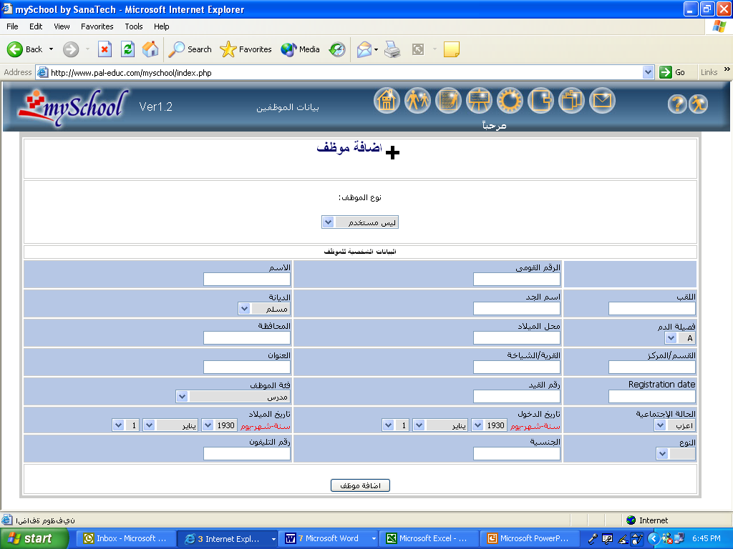

Figure 3. Automation Software (Arabic Interface)

Training
Modern teaching techniques that encourage critical thinking and problem-solving and appropriate computer equipment and software are being introduced into the schools as a way of enhancing the teaching of the current national curriculum. Teachers are trained to integrate appropriate technology and methods into their standing curriculum using current best practices in education that are aligned with international technology education standards and can be effectively adapted for use in the Egyptian school environment. The demonstration programs will result in high-quality models based on sound educational research using cutting-edge technology, all in a realistic Egyptian educational environment. Portfolio and traditional assessment tools are used to evaluate the success of both the teacher training and implementation. For example, each school is assisted in building a web-site that showcases students' and teachers' use of technology as an application and learning tool. In addition, collaborative projects with other schools within Egypt and around the world will help to improve communication and technology skills for both students and teachers.

Participants in the Ed Tech in Schools project include a school administration team composed of the Principal, Vice-Principal, Academic Dean, Financial Director, Information Technology Director and Librarian. Educators from all subjects in all grades receive training to develop the entire school as a technology-enhanced learning environment. All educators and administrators take the International Computer Driving License exam at the end of training and computer teachers take the Microsoft Office User Examination. Computer technicians at each school receive orientation training, an A+ certification course and participated in the installation process. The total number of participants includes 1,800 educators and 100 administrators working with 23,000 students and their families.

Training is delivered to educators in Basic Computer Proficiencies, and continues over the course of the project delivering educational methodologies workshops that assist educators in developing technology-enhanced lessons using educational software and the internet. Administrators are provided with Technology and Management Skills training prior to the installation of the equipment, and receive additional training over the course of the project to develop sustainability plans. Approximately one third of the teachers are trained each year beginning with the first grade in each stage in the first year and moving through the grades in each stage over three years. Master trainers are identified each year and trained in adult training methods and can be used to assist in the delivery of educational technology training to parents, students, community members and teachers from other schools. They are encouraged to mentor and train new teachers and at their school, participate in hosting regional and local conferences, and can be used to teach after school and summer courses in the school computer labs.
Monitoring and Assessment
School administrative teams and teachers completed pre-workshop surveys prior to the start of the project to establish a baseline for participants and to provide statistics regarding computer proficiency. These will be repeated at the end of the project. School administrators and educators initially complete and then repeat self-assessments based on The International Society for Technology in Education's National Educational Technology Standards (ISTE 2003). These cover for educators - basic computer proficiencies, internet skills, advanced proficiencies, and for administrators – use of computers in school administration and internet use.
Schools and teachers are assessed through the development of web-based portfolios that highlight their progress through training and the implementation of the educational technology skills they have learned via application in the school environment. All participants’ work is linked to individual web-pages. An electronic or web-based portfolio makes it possible to organize a large amount of participants’ work. Research indicates that many teachers find it encouraging to showcase their work on their own web-site and developing electronic portfolios also adds to their technology skills. Electronic web-based portfolios allow teachers to share work with each other and with their students, administrators and parents. Teachers can continue to develop their portfolio after finishing their training and can present themselves to their community through their web-page. In this way, the portfolio becomes an instrument in 'life-long learning' (Wielenga & Melisse 2000).
Participant-developed lessons are located on-line at the Educators’ Resource Network in a searchable database and include both lessons and their assessments. All school administrative plans for sustainability, automation, collaboration and assessment are also on-line. Training workshops are evaluated over the course of the project and are available on-line. Statistical reports by project and school are accessible on the internet.
Regular site visits to each school by the PfCE staff are held twice a year. PfCE teams conduct observations, interviews, meet with all school groups and attend a parent meeting organized by the school. School reports from these site visits are added to the on-line database for tracking of school progress. Technology visits are made on a regular basis by PfCE or sub-contractor personnel to ensure the smooth operation of all equipment in the school. Technology status reports are compiled for each school regularly. Schools are required to complete an annual report and inventory documenting location of equipment and assessment of the use of software applications and hardware in each venue: administration, classrooms, staff rooms, computer labs, libraries, and science labs.

Sustainability

Demonstration schools work in community-based collaborative administrative teams, facilitated by PfCE, to create sustainability plans for how they will pay for the cost of upgrading hardware and software, facilitate connectivity and purchase supplies during and post-project funding. These plans are assessed and evaluated during strategic planning seminars with administrators on a regular basis and posted on the web-site. Egyptian technology service providers are identified by the PfCE team to assist schools in the implementation of their sustainability plans.
Schools may use their upgraded computer labs as community centers using Master Teachers to deliver training to local businesses, parents, community members, teachers from other schools and students after school hours and during the summer. Technology Service Providers (TSPs) enter into agreements with PfCE, representing the network of school communities, in achieving the school sustainability objectives. TSP agreements negotiated by the PfCE team on behalf of the schools include financial investment for these objectives in exchange for profit sharing to fund school sustainability and replicability of the model to additional new schools.
At the end of the contract period the equipment, maintenance and operation of the technology components and coordination and management of school sustainability plans between TSPs and schools will be handed over to a centralized legacy institution. This institution will be a non-governmental organization (NGO) formed to continue to implement and support an integrated solution combining various sustainability ideas developed by schools and TSPs in order to enhance the quality of education in Egypt, thus bridging the digital divide by building the capacity of the Egyptian workforce. The NGO with input from school communities will facilitate the collaborative efforts of school management team visions for integrating technology in the school and community with TSPs. Direct operational constraints of the project at each school will be defined by the school, but it is anticipated that all will operate under the general program control of the legacy institution (Fig. 4).
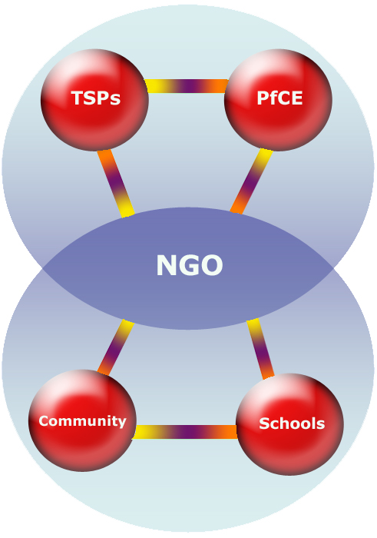

Figure 4. Egyptian School Community Sustainability Model

Project-wide sustainability plans include providing low-cost centralized resources and connectivity for schools post-project and for the addition of new schools, profit-sharing income from phone calls by parents accessing the school management software system using interactive voice response systems, the building of wireless internet service provider infrastructures at each school to connect communities to the internet, and the provision of low-cost computers to teachers, students, parents and community members.

Summary

The PfCE Ed Tech in Schools project seeks to introduce technology in the early stages of Egyptian education, whereby students gain familiarity with technology applications and enter the culture of using the Internet as a knowledge source and communication medium. The courses in the secondary school stage of this program will increase the supply of individuals with market responsive technology skills, who can either directly join the workforce or pursue higher education in technology-related fields. Teachers involved in the project are expected to begin integrating constructivist learning methodologies in their classrooms moving towards a collaborative student-centered and project-based classroom environment. Teachers are also expected to integrate and assess the technology-enhanced lessons that they and other teachers have developed. Administrator and community sustainability plans and visions will help to build technology awareness, acceptance and expertise into the community as a whole. The success of the demonstration and its wider replication may lead to institutionalizing the provision of these methods and skills in school communities. It is expected that this will take the form of an operating non-governmental organization with capacity to manage and sustain the initiative after project expiration.

References

Ministry of Telecommunication and Information (1999). National Plan for Telecommunication and Information. Cairo, Egypt: Arab Republic of Egypt.

U.S. Department of Education (2002). 2000 Program Report and 2002 Annual Plan. [Online]. Available: http://www.ed.gov/pubs/AnnualPlan2002/index.html

Resnick, M. (2002). Rethinking Learning in the Digital Age. The Global Information Technology Report: Readiness for the Networked World. New York: Oxford University Press: World Economic Forum.

International Society for Technology in Education (ISTE) (2003). ISTE / NCATE Standards for Educational Technology Programs. [Online]. Available: http://cnets.iste.org/ncate/index.html

Knezek, D., Kelly, M.G., Thomas, L., & Bitter, G. (2000). National Educational Standards Technology Project for Students: Connecting Curriculum and Technology. Eugene, OR: International Society for Technology in Education.

Wielenga, D., & Melisse, R. (2000). Proving Competence: Integrative Assessment and Web-based Portfolio System in a Dynamic Curriculum. Society for Information Technology and Teacher Education International Conference 2000(1), 112-117. [Online]. Available: http://dl.aace.org/458

Means, B., Blando, J., Olson, K., Middleton, T., Morocco, C., Remz, A., & Zorfass, J. (1993). Using technology to support education reform. Washington, DC: U.S. Department of Education. [Online]. Available: http://www.ed.gov/pubs/EdReformStudies/TechReforms/

President's Committee of Advisors on Science and Technology. (1997, March). Use of Technology to Strengthen K-12 Education in the United States. [Online]. Available: http://www.agiweb.org/hearings/pcastedu.html

